RESUME

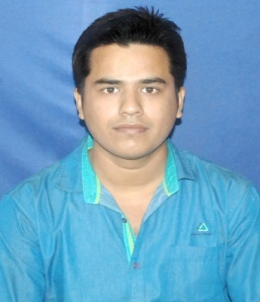

RAVI KUMAR

TOWN-BOKARO STEEL CITY
SECTOR-9/D
STREET-38
QUARTER.NO-1279

EMAIL:-Ravi5538kumar@gmail.com

MOBILE NO: +91-9431514408

Carrier Objective:
To secure a challenging position where I can effectively contribute my skill in the field electrical enng,possessing competent Technical Skills.

Qualification

ACADEMIC PROFILE
EXAM | NAME OF THE INSTITUTE/UNIVERSITY | YEAR OF PASSING | MARKS (%)
Diploma 1st Year | G.G.S POLYTECHNIC COLLEGE,  P.S.B.T.E ,CHANDIGARH. | 2011 | 67%
Diploma 2nd Year | G.G.S POLYTECHNIC COLLEGE,  P.S.B.T.E ,CHANDIGARH. | 2012 | 70%
Diploma 3rd Year | G.G.S POLYTECHNIC COLLEGE,  P.S.B.T.E ,CHANDIGARH. | 2013 | 73%
Class X | B.I.V 9/D, C.B.S.E, DELHI | 2010 | 66.6%

COMPUTER SKILLS
- Operating System Windows2000,7 home basic

- Languages C ,Assembly language.

PROJECT PROFILE
- “Thermoeletricgeneration,Water level Indicator.”.”

TRANNING PROFILE
TRANNING | “6th week Training in “P.K TRANSFORMER PVT.LTD.”
EXPERIENCE | Six Month Working on “Injection Molding Machine”.
 | One year six months working in Reliance Industries pvt.ltd; under Excel Technical services".

PERSONAL DETAIL
Name: Ravi kumar
Date of Birth: 20-02-1995
Father’s name: Mr.Manoj kumar singh
Sex: Male
Marital Status: Single
Languages : English, Hindi, punjabi
Nationality: Indian

Permanent Address: Village:-bhajawna,

P.O:- Nachap
P.S:- Manjhi

Dist:-Chapra(Bihar)India

Pin:-801502

Place-Bokaro steel city.

Date:-10-01-2017

Ravi Kumar

( Signature)

