RESUME

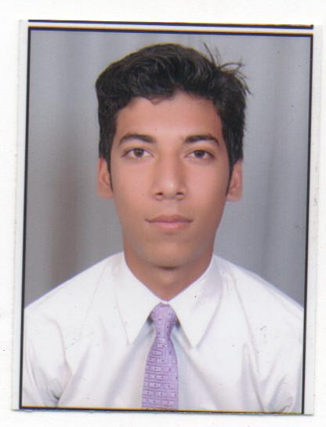 H No. 741/24
DLF COLONY
Rohtak-124001 Haryana

Contact No.+91-9138911600
+91-9996337783
Email:takkar.mohit95@gmail.com

MOHIT

I am a fast learner, sincere, hardworking, capable of representing myself in a competitive environment and I believe in action not in position .I Take initiatives and work in a planned manner to achieve the defined targets.

Career Objective

Intend to build a career with leading company, which will help me to explore myself fully and realize my potential. Willing to work as a key player in challenging & creative environment.

Academic Qualification

- BBA from M. D. University, Rohtak with 62%
- Sr. Secondary from H. B. S. E. Board with 72%
- Matric from C. B. S. E. Board with 79.4%

Computer Skills

- Basic knowledge of Computer
- MS-Office & Internet

Experience

- 3 Year experience in multi level marketing organization and having a team of more than 500
People and dealing with computer education
- Managing events every week at district level
- Last Salary 1.8 Lakhs/anum

Achievements

- Represented Haryana at public speaking in Delhi & Chandigarh
- Silver representative at eBIZ.COM PVT.LTD.

Strengths:

      - Good team building
      - Good marketing sense
      - Selling skills
      - Presentation skills
      - Good at making public relation
      - Public speaking
      - Motivator & inspirer

Hobbies:

- Watching movies
- Hang out with friends
- Playing outdoor sports
- Travelling

Personal details

Name : Mohit
Date of birth : 5th June, 1995
Father’s Name : Sh. Ashok Kumar
Nationality : Indian
Gender : Male
Martial status : Unmarried
Languages Known : English & Hindi

Date:
(Mohit)
Place:

