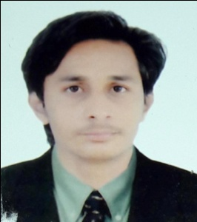
RESUME

Name : BANDI MAAZ MOHAMMED SALIM
Address : 14-TRANSPORT NAGAR SOCIETY MODASA
TA MODASA DIST: ARVALLI PIN-383315
Contact : +91-7046392856
Date of Birth : 30-10-1999
Sex : Male
Marital Status : Unmarried
Religion : Muslim
Nationality : Indian
Language Knows : Gujarati,Hindi, English
Computer Knowledge : CCC.TALLY Basic knowledge

Education Qualification: Are as under
Sr. No. | Name of Degree | Name of Uni./Board | Year of Passing | Percentage %
1 | S.S.C | GSEB | MARCH 2015 | 67.00 %
2 | H.S.C. | GSHEB | MARCH 2017 | 58.15 %
3 | BE (CIVIL) | GTU | RUNNING | -
\

Declaration :

I hereby declare that the above mentioned information is correct up to my knowledge and I bear the responsibility for the correctness of the above mentioned particulars.
Date :
Place : MODASA Yours Faithfully
M.S.BANDI

