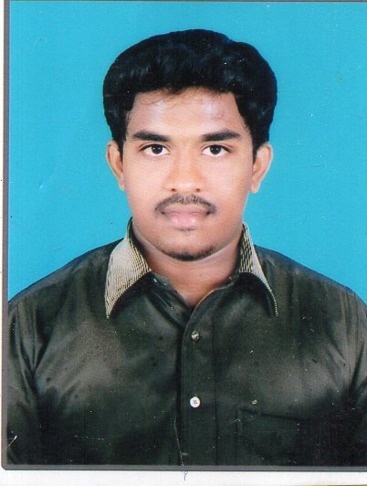 OBJECTIVE
SUGUMAR.V

Email : sugumarcc@gmail.com
Contact No : +91 9442624222

- Looking to join a progressive organization that has a need for construction / project management and offers opportunities for advancement
- Of professional and personal status, while being resourceful, innovative and flexible.

CREDENTIALS
- Bring out new ideas through lateral thinking.
- Self-Motivated person with a high morale and positive attitude towards life.
- Possess good leadership abilities.
- Ability to easily understand and adapt to new technological trends.

ACADEMIC QUALIFICATIONS

Graduation | Board | Year of passing | Percentage
Sslc | Tagore Matriculation Higher Secondary School. Deviyakurichi, Salem. | 2009 | 62
H.Sc | Mount Park Matriculation Higher Secondary School, Thiyagadurgam | 2011 | 66
B.Tech | Dr.M.G.R. Educational & Research University  Maduravoyal. | 2015 | 76
M.Tech | Dr.M.G.R. Educational & Research University  Maduravoyal. | 2017 | 83

PROJECTS

Title | Description | Concepts
Evaluation of expert system to eradicate various kinds of disputes in major contracts of construction projects | Construction contracts provide rise to disputes of unusual difficulty.The performance of many construction contracts run over much longer periods than most other forms of commercial contract,with potential scope for disagreement and financial disagreement arising constantly during the construction periods. | Identifying the different factors that causing disputes in construction projects.
An experimental investigation ground granulated blast furnance slag. | The objective of this project to avoid cracks and expansion,Increase in workability,we can get more strength at very low cost. | Method of extracting get more strength at very low cost.

CO-/EXTRA –CURRICULAR ACTIVITIES

- Presentation certificate for model making in The International Conference on Earthquake Resistant Construction Practices held on 27th and 28th of July 2012.
- Participation certificate on Advanced and Innovative Scientific & Technological Project Exhibition.
- Participation certificate for National Conference on Design and Construction of Precast Concrete Structures sponsored by Council of Scientific and Industrial Research.
- Organizer Certificate For Poster Presentation & Chess Competition conducted in AAKRITI’14 by the Department of Civil Engineering on 8th & 9th Sep 2014.

ACHIEVEMENTS

- Certification in all the above participated events.
- Participated and presented a paper on the above project Effect on (International Conference held at KRCT Trichy

INTERPERSONAL SKILL

  - Ability to rapidly build relationship and set up trust.
  - Confident and Determined.
  - Ability to cope up with different situations.
  - Curiosity to know the things related to my job.
  - Leadership skills.
  - Punctuality

REFERENCES

Mrs.Dr. T. Felix kale Head of Department, Civil Engineering, Dr. M.G.R University.
Prof , Mr.Raja ramachandran, Civil Engineering, Dr. M.G.R University.

PERSONAL PROFILE

Father’s Name : D.Veerappan
Mother’s Name : V.Gandhimathi
Sex : Male
Nationality : Indian
Date of Birth : 07/04/1994
Languages Known : Tamil, English and Hindi
Hobbies : Traveling, Dancing, Exercise and Playing Cricket.

PERMANENT ADDRESS

D.veerappan,
NO. 25/J,New street,
Ulundurpet(T.K),
606107,
Villupurem(D.T)

