2018
INDROJIT LOHAR
CV & ALL ESSENTIAL DOCUMENTS
1.PHOTO IDENTITY PROOF
2. RESIDENTIAL PROOF
3.QUALIFICATION CERTIFICATES

BIODATA
PERSONAL DETAILS
NAME:- | Indrojit Lohar  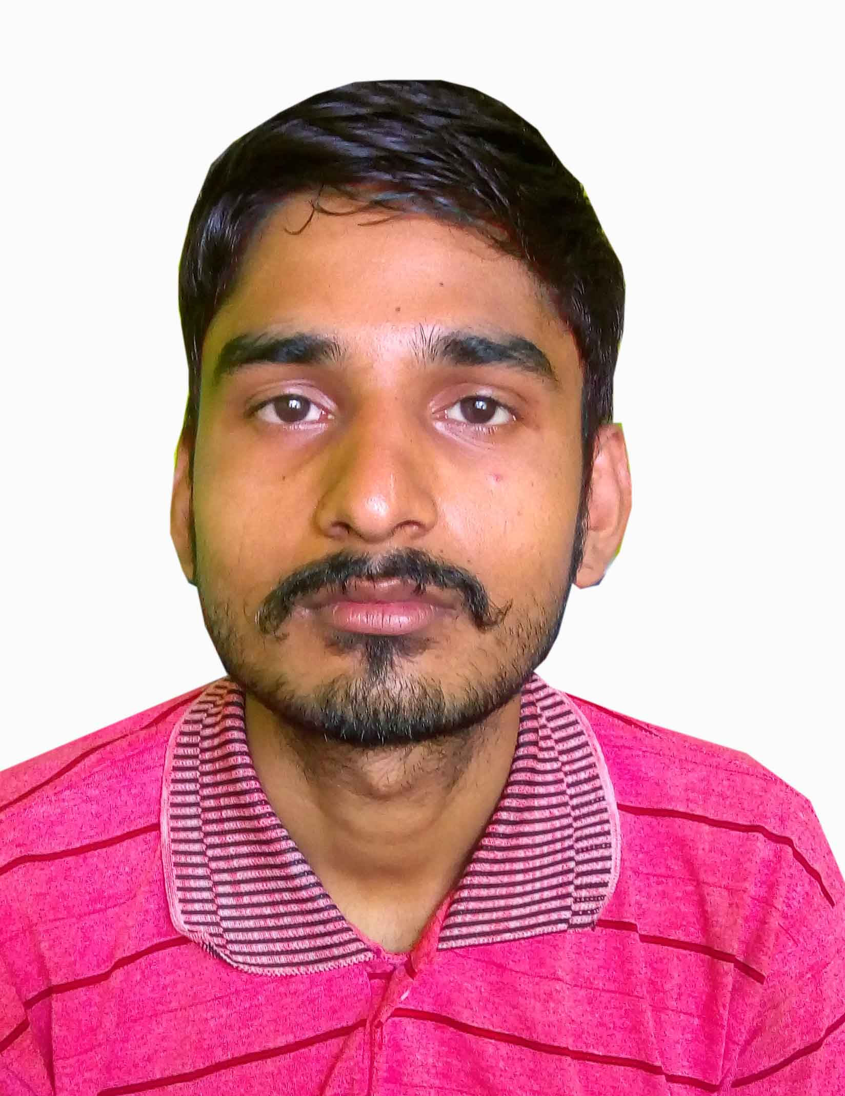  PASTE PASSPORT SIZE PHOTOGRAPH HERE
FATHER’S NAME:- | Sahadeb Lohar
MOTHER’S NAME:- | Bishoka Lohar
DATE OF BIRTH | 10.08.1996
ADDRESS:- | Vill:-Shivmandirpara P.O:-Harishchandrapur P.s:- Harishchandrapur Dist:-Malda Pin:-732125
MOBILE NUMBER:- | +9534048214
MARITAL STATUS:- | Unmarried

EDUCATIONAL DETAILS
Secondary Qualification:- Passed 9th passed in West Bengal

Panasonic P55 Novo (16GB, Champagne Gold)

