CURRICULUM VITAE
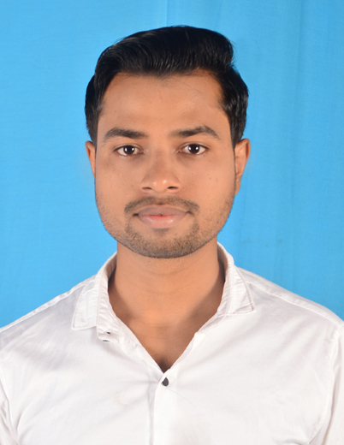

VINAY KUMAR PANDEY
Email ID : vinaypandey296@gmail.com
Contact No. :9064271832,9709250515

CAREER OBJECTIVE

- To work with on organization where i can implement whatever knowledge i have as well as continuously learn in order to achieve success and optimum career growth by fulfilling organizational goals.

ACADEMIC QUALIFICATION
DEGREE/ CERTIFICATE | BOARD/UNIVERSITY | SCHOOL/ COLLEGE | YEAR OF PASSING | PERCENTAGE
B.TECH  (MECHANICAL) | RANCHI UNIVERSITY | NILAI EDUCATIONAL TRUST’S GROUP OF INSTITUTIONS,  THAKUR GAON, RANCHI | 2017 | 68.75%
12TH | J.A.C | ST.PAUL’S COLLEGE,RANCHI | 2013 | 50%
10TH | W.B.B.S.E | JHALDA HINDI HIGH SCHOOL | 2010 | 51%

PROJECTS

PROJECT NAME: - ADJUSTABLE CAR

- Description: - The Purpose of this project is adjusting the car according to space. We know that, the parking places are full of crowd and then we are face problem for parking our cars.
- Responsibilities: - Work as an active member in a group of 5 people and assisted all the team members.

TRAINING ATTENDED

- Undergone Vocational training at BOKARO STEEL PLANT (SAIL/BSL), Bokaro for the period of 30 days

TECHNICAL SKILLS

- Languages : C,C++
- Equipped With
- Operating System : Windows XP,Windows7,Windows 8
- Microsoft Word, Power Point and MS Excel.

OTHER SKILLS

- Very Good Logical and Analytical Skills
- Excellent in Interpersonal and Decision Making ability.

ACHIEVEMENT

- Man of the match selected in tournament.

STRENGTH

- Positive Attitude, Smart Working, Hard Working, Self Confident, Quick Learner, Good Listener.
HOBBIES

- Playing Cricket, Listening to Music, Singing and Teaching.

PERSONAL DETAILS

Name : Vinay Kumar Pandey
Date of Birth | : | 21/03/1994
Father's Name  Address | :  : | Manoj Kumar Pandey  At-Ojhapara jhalda, P.O-Jhalda, P.S-Jhalda, Dist-Purulia, Pin-723202, (W.B).
Nationality | : | Indian
Religion | : | Hindu
Gender | : | Male
Marital Status | : | Unmarried
Language Known | : | Hindi,English,Bengali.
DECLARATION
I hereby declare that all the above Information is true to best of my knowledge

Place: Jhalda
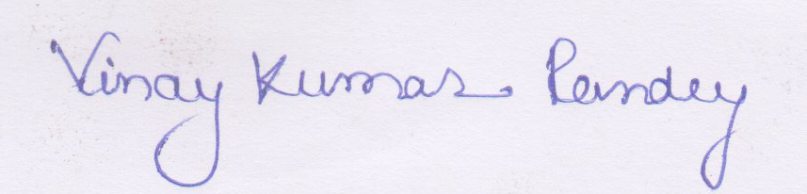

Date: 29/05/2018
Signature

