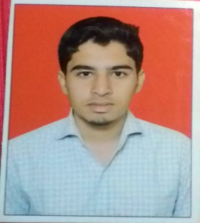
RESUME

Name : Mudassar md.rafique Qazi

Mobile : 7798361567, 9595121787

Email : mudassarqazi88@gmail.com

Objectives

To work for an organization which provides me the opportunity to improve my skills and knowledge to growth along with organization objective?

Educational Qualification

Sr. No. | Qualification | Board/ University | Year of Passing | Class/ Grade | Percentage
1 | Diploma Electrical Engineer | Mumbai | 2014-17 | First Class | 60.73%
2 | H.S.C. | Pune Board | 2012-13 | Second Class | 57%
3 | S.S.C. | Pune Board | 2010-11 | Second Class | 55.60%

Other Technical Qualification

Sr. No. | Qualification | Board/ University | Year of Passing | Class/ Grade | Percentage
1 | Computer Operation with (MS-CIT) | Mumbai Board | May-2012  (6 Months) | First Class | 61%

Project Work

Energy conservation in library

Experience

- Just a fresher.

Extra Curricular Activities

• Played Games at college & school level.
• Participant in the national level project competition event of wisotech-17

in 2017.
• Participant in poster presentation and paper presentation in national level.

Special Skills

- Flexible and innovative.
- Converting innovating ideas to design.
- Goal oriented, positive and supportive.

Interests

- Machine Repair, Internet surfing, swimming, playing cricket.

Languages Known

- English, Hindi, Marathi, Urdu.

Personal Detail

- Name : Mudassar md.rafique Qazi
- Father’s Name : Md.Rafique makhdoom Qazi
- Mother’s Name : Shamshad md.rafique Qazi
- Date of Birth : 26/3/1996
- Gender : Male
- Permanent Address : , 124,G.H.NO.1 bijapur naka Solapur-413005

Declaration

I hereby affirm that the above information is true to the best of my knowledge.

PLACE: Solapur

DATE : Mudassar md.rafique Qazi

